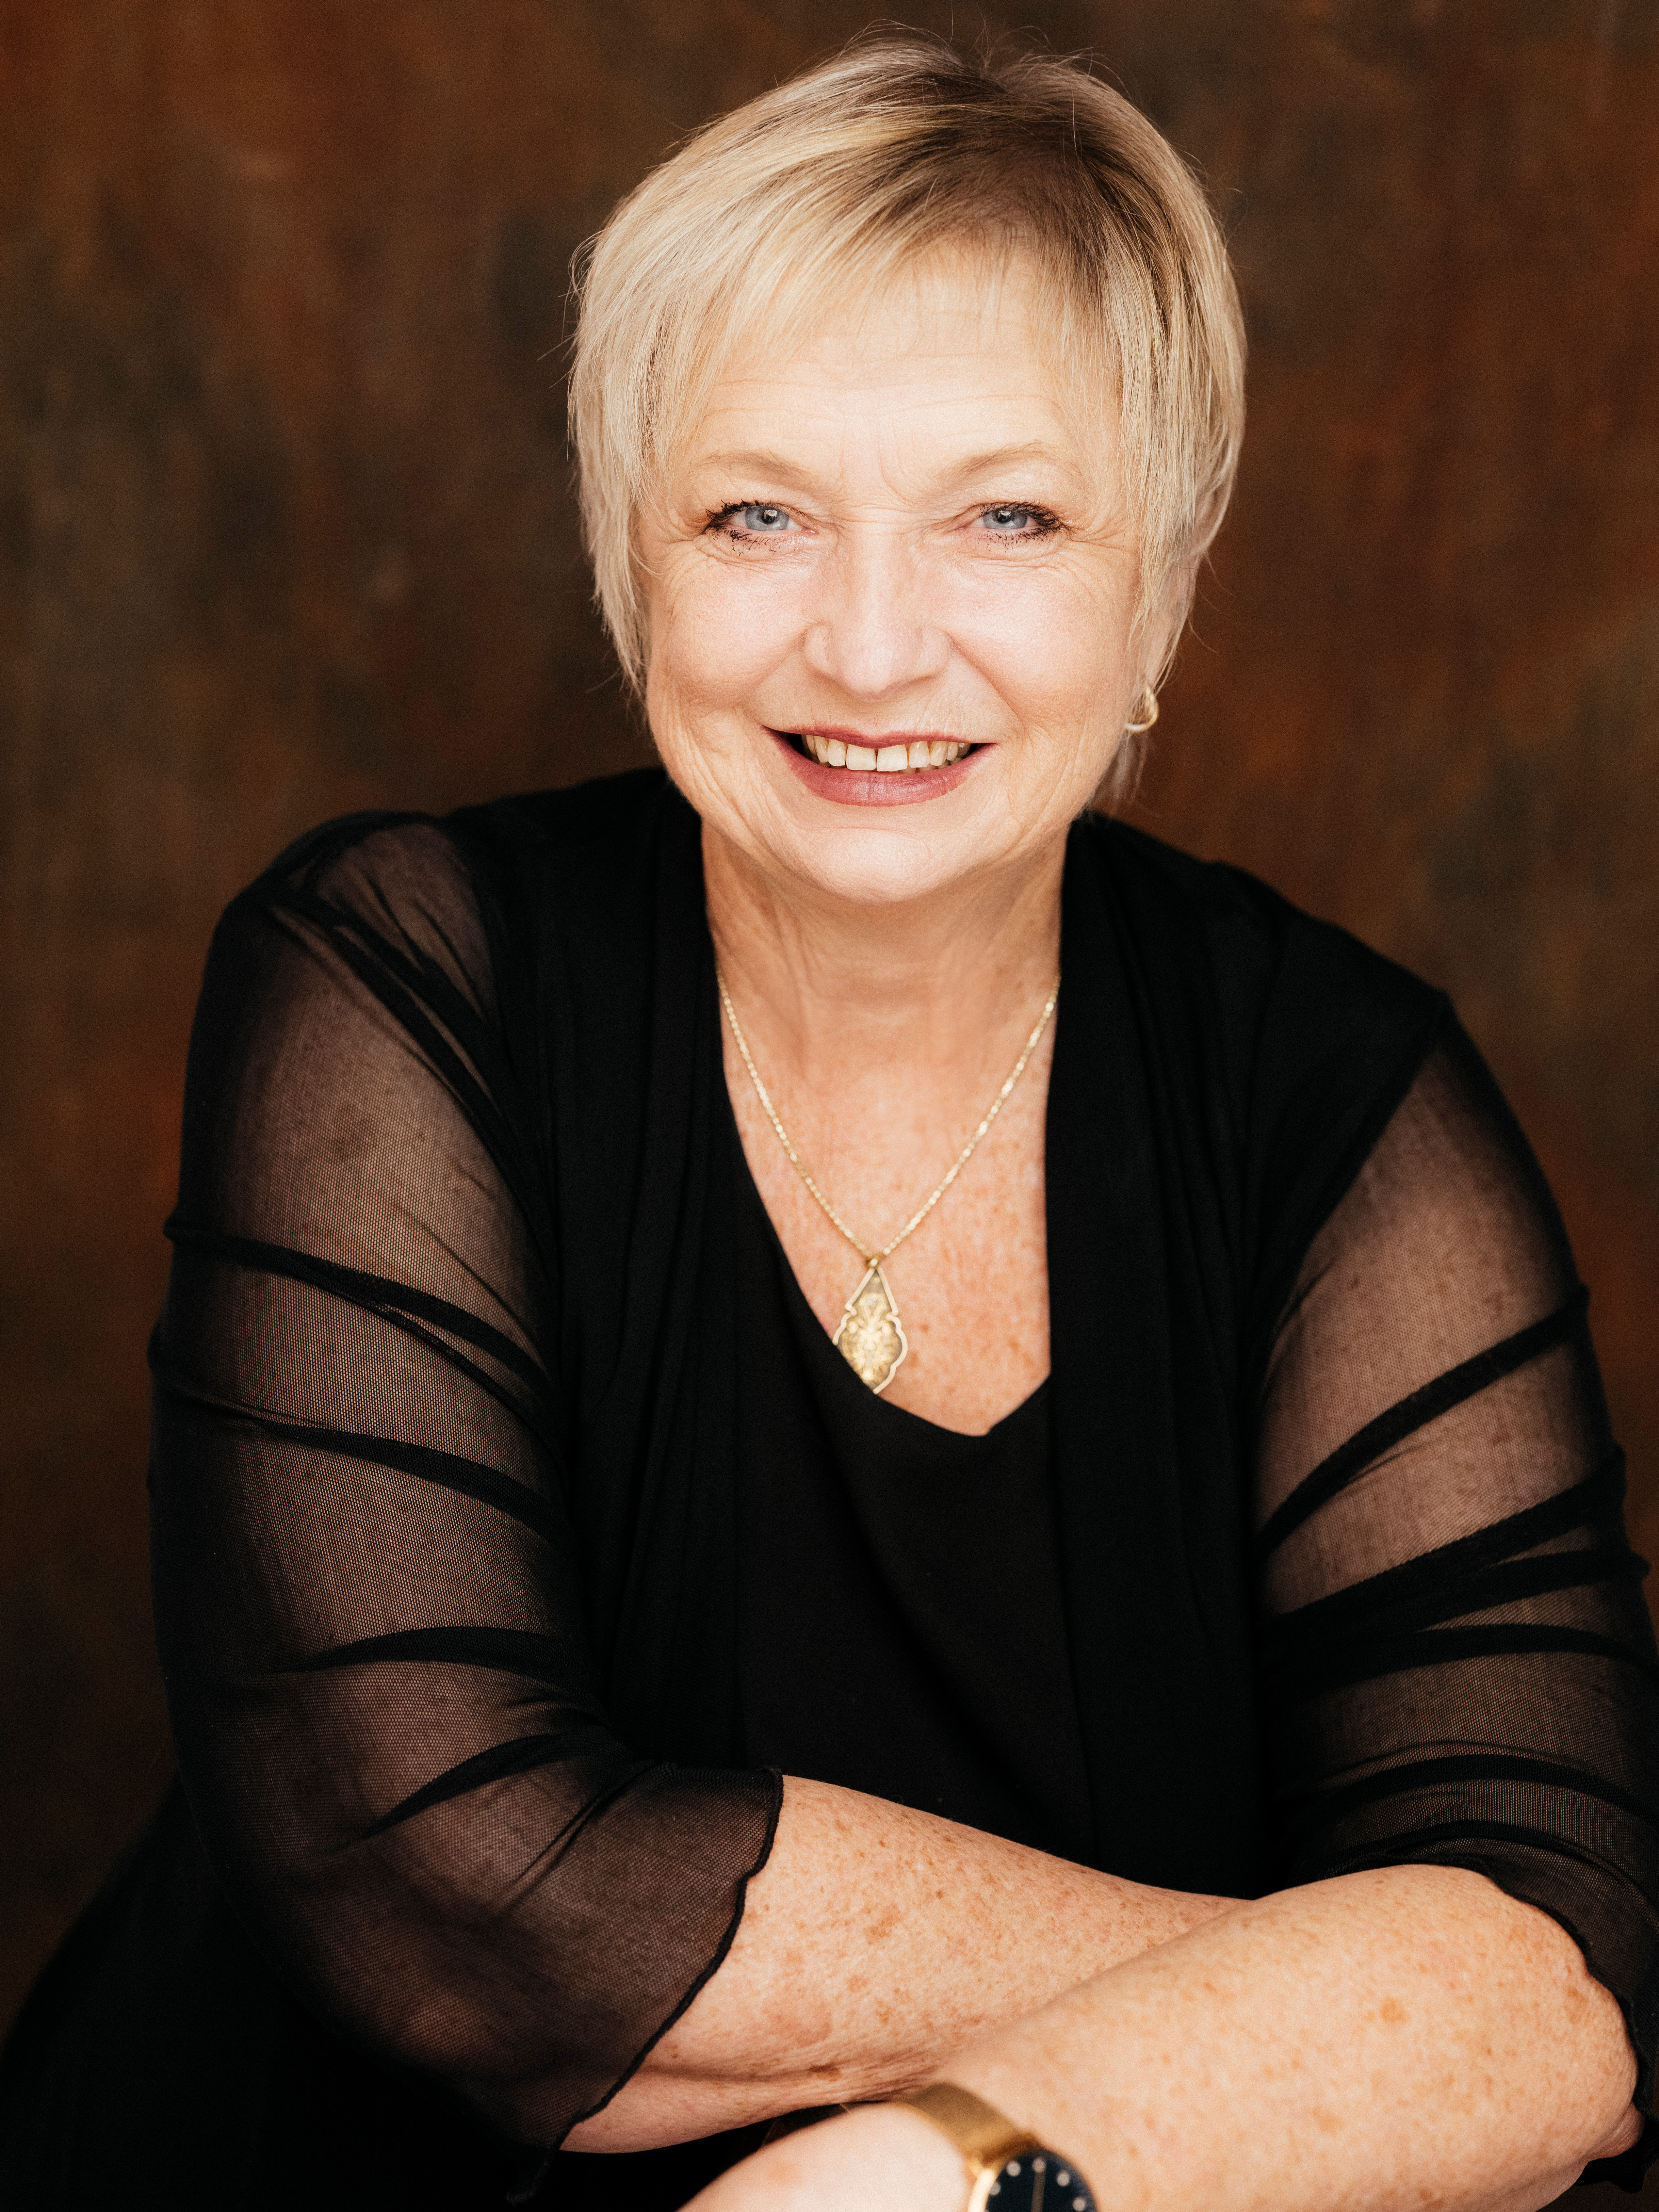

JACQUI HALL CUNY
PhD(Music), M. Mus. Studies, B. Mus., B.A.

Performance Coach | Actor | Director | Musician | Researcher

37 Whites Road, Manly West, QLD 4179 | P: 0407 157665 | E: Jacquicuny@gmail.com

TERTIARY EDUCATION
2022 PhD (Music), Queensland Conservatorium, Griffith University
2018 Master’s in Music Studies with Distinction (Vocal pedagogy — majoring in contemporary voice), Qld Conservatorium, Griffith University
1980 B. Mus. (majoring in singing performance and teaching, piano), Qld Conservatorium of Music
B.A. (majoring in drama and music —singing, piano, composition), University of Queensland

Additional Training
2019 Nikki Flacks — Acting with Passion course – Melbourne
2018 Michael Chekhov training — Bethany Caputo, New York
Larry Moss – The Intent to Live Master Classes, Brisbane
Sanford Meisner training — Scott Williams, Brisbane
2016 Ivana Chubbuck Acting Technique — Anthony Brandon Wong
Sceneorama at the fACTORy — Christopher Sommers
2015 Stella Adler and Uta Hagen workshops in New York
Larry Moss — The Intent to Live Master Classes, Sydney
Sceneorama at the fACTORy — Christopher Sommers, Brisbane
Screen Acting Foundation Course — Phil Holder, The Warehouse, Gold Coast

1995—1997 Jo Estill Advanced Vocal Training — University of Sydney, National Voice Centre
Postgraduate Courses
1984—1986 Wayne Carey — Directing the Actor; Kristin Linklater — Freeing the Natural Voice;
Ros Gentle — Creating a Real Response — Actors Centre, NSW
1966—1976 Classical ballet (RAD), jazz and tap
Ongoing singing, acting and pedagogical training via private tuition, masterclasses, and workshops, including those delivered by ANATS, MTEA, Jeanette LoVetri.

EXPERIENCE PERFORMING AND DIRECTING

Professional Theatre — Performing
2006 Twelfth Night Theatre, Brisbane, My Way — A Tribute to Frank Sinatra
2005 Twelfth Night Theatre, Brisbane, Carousel — Ensemble (u/s Nettie, Mrs Mullins)
1992 Q Theatre Better Known as Bee, Q Theatre, Sydney — multiple roles
1991 Kevin Jacobsen, Return to the Forbidden Planet, Capitol Theatre, Sydney — Gloria
1990 Her Majesty’s, Buddy — The Buddy Holly Story, Her Majesty’s Theatre, Sydney — Vi Petty, Ensemble
1988 Really Useful Co, Starlight Express, Apollo Victoria, London — booth singer
1987 Gospel Concert Tour promoting original album Another Statistic
1986 Bill Kenwright Productions, Jeanne (Rock Opera), Birmingham Repertory and Sadlers Wells Theatre, London — Saint Margaret
1985 Manchester Opera House, The Pirates of Penzance, Manchester — Edith
1984 Victorian State Opera, The Pirates of Penzance, National Tour — Ensemble (u/s Edith)
1983 Adelaide Festival Trust, The Sound of Music, National Tour — Ensemble (u/s Sister Sophia)
1982 Nimrod Theatre, Candide, Seymour Theatre, Sydney and Comedy Theatre, Melbourne — multiple roles, u/s Cunegonde (Director — John Bell)
Q Theatre, Phantom of the Opera, Bankstown, Sydney — Christine Daie
1982 Qld Theatre Company, The Circle, Brisbane — Understudy
1981 Qld Theatre Company, Annie, Brisbane, and Qld Tour — Star to Be, Boylan Sister, Ensemble, (u/s Grace Farrell)

Professional Tertiary Directing and Music Directing
1992—1996 Aquila College of Ministries, Sydney — A Man to Fulfil My Purpose, Stand Strong, Spikes, Shout, The Prodigal
Books by Amanda Fergusson (staff) and composed and performed by students — my role was Director and Associate Music Director, including arranging and scoring underscore and assisting with lighting design.

Pro-am and Community Theatre — Performing and Directing

Savoyards 1999—2021
- The Drowsy Chaperone — Mrs Tottendale
- Into the Woods — Witch
- The Boy from Oz — Marion Woolnough
- Oklahoma! — Aunt Eller
- Nice Work If You Can Get It — Duchess Estonia Dulworth
- How to Succeed in Business Without Really Trying – Miss Jones
- Annie — Miss Hannigan
- Thoroughly Modern Millie — Muzzy
- Miss Saigon — Assistant Vocal Director
- Jesus Christ Superstar — Music Director and Conductor
- The Sound of Music — Maria

Harvest Rain Theatre Company 2001—2005
- Into the Woods — Cinderella’s Stepmother
- Oliver! — Widow Corney
Casting and vocal direction of multiple large-scale productions for Redlands College, Brisbane, since 2011 including:
- Oliver!, Beauty and the Beast, The Secret Garden, The Sound of Music, My Fair Lady, The Little Mermaid, and Into the Woods.

Film and Television Roles
2016 Adele (Gonella Productions) — Mrs Williams
2010 Charge Over You (Triumphant) — Dr Lillian Boyd
2009 In Her Skin (Liberty Films) — Susan

TEACHING
2021—2023 Synergy building workshops and Masterclasses with graduates from Qld Conservatorium and visiting MT cast members (eg, Hamilton)
2015—2021 Upbeat Arts/School of Hard Knocks — musical theatre stream, Brisbane. Teaching musical theatre, including singing, acting and dance; devising performance pieces for 12 to 18 performers presented at QPAC and the Queensland State Library
2014—2019 Australian Dance Performance Institute — Brisbane (now Qld College of Dance). Teaching singing and audition preparation, lecturing in musicology, theory and song analysis, for the Diploma of Art in Musical Theatre and Commercial Dance
2007 ongoing Redlands College, Brisbane— singing, piano, theory, audition preparation
2006—2018 Moreton Bay Boys College, Brisbane — singing and piano
1992—1996 Aquila College of Ministries, Sydney — drama
1988—1989 London Studio Centre, London — singing and audition preparation
1987—1989 Arts Educational Schools, London — singing and piano

For the past 43 years, I have maintained a private studio, teaching and coaching all age groups in singing (all styles), piano and audition preparation for MT university courses nationally. My students have successfully attained places in major tertiary Musical Theatre courses in Australia (QCGU, WAAPA, VCA, FU, Elder).

RESEARCH AND PUBLICATIONS
- PhD (Music) — exploring performance artistry in Musical Theatre acting and singing
  - Thesis: Musical Theatre Performance Synergy — Exploring Elements, Constructs and Practice
- Master’s in Music Studies — training of Australian tertiary musical theatre students
  - Dissertation: Training the Acting Singer: A Snapshot of How Musical Theatre Students Learn to Synthesise Singing and Acting in an Australian Tertiary Environment (High Distinction)
- Journal articles:
  - Exploring Musical Theatre Performance Synergy: Accessing Seven Performative Processes (Studies in Musical Theatre, Vol 16:2, July 2022)
  - Musical Theatre Strategies for the Private Singing Studio (ANATS Journal, Australian Voice, 2018)
REFEREES
Jason Langley  Director, Dramaturg, Performance Coach  E: jason.langley@mac.com | Assoc Prof. Dr Irene Bartlett  Senior Lecturer, Coordinator, Voice and Pedagogy  Queensland Conservatorium, Griffith University  E: i.bartlett@griffith.edu.au

